**The following steps will teach you how to start the Raspberry Pi system image**

1. **Power supply:**  
   The Raspberry pi board can adopt two power supply modes:  
   1) You can use Micro usb cable and power adapter to supply power. The best power adapter is 5V/2.5A.  
   2) You can connect the expansion board of Yahboom TrikeBot car to Raspberry pi board by 40pin line to supply power to it.  
   (In case of stable power supply: red power indicator LED on, and the yellow-green signal indicator LED will flash occasionally)
2. **start the system image**

**Case 1:** If you are using system image for TrikeBot car which we provide.

(At this point, Raspberry Pi is treated as a router)

1. You can connect your computer to the wireless network of the TrikeBot car, then use PuTTY software to remote login into the system.

Name of wireless network:Yahboom_TrikeBot

(Note : This software in the Tools folder)

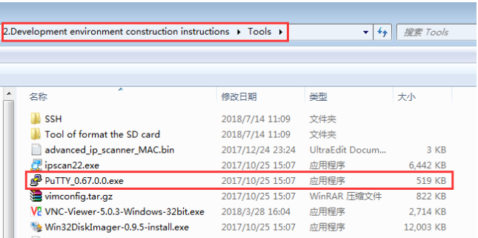

User name: pi

Password: yahboom

Port: 22

IP address: 192.168.0.1

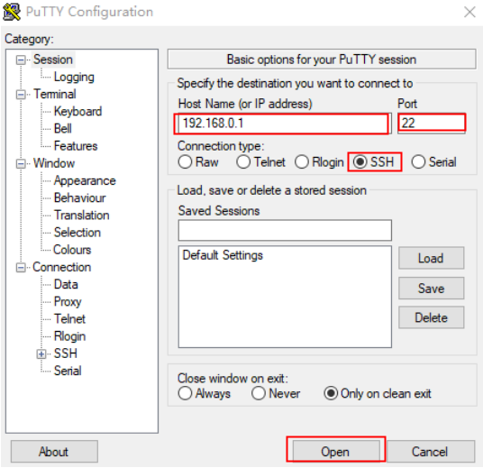

As shown in the figure below.

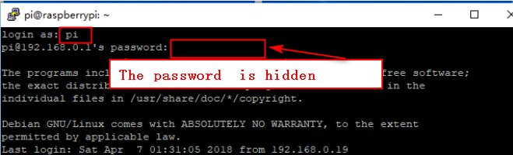

**Case2-1:** If you are using the official original system image of the Raspberry pi or your system image.

After the system image is written, you should insert the SD card directly into the Raspberry Pi to run. we need to connect the monitor, mouse and keyboard. After entering the system, you can connect to the currently available WIFI(Raspberry Pi 3 Mode B+ can be connected to 5G WIFI). You need to open the command line terminal in the Raspberry Pi system and input：ifconfig to search the IP address of the Raspberry Pi, as shown in the figure below.

(Note:just for example:my IP address of the Raspberry Pi is 192.168.1.184))

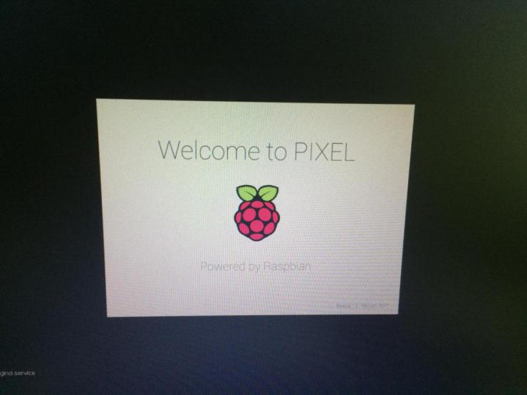

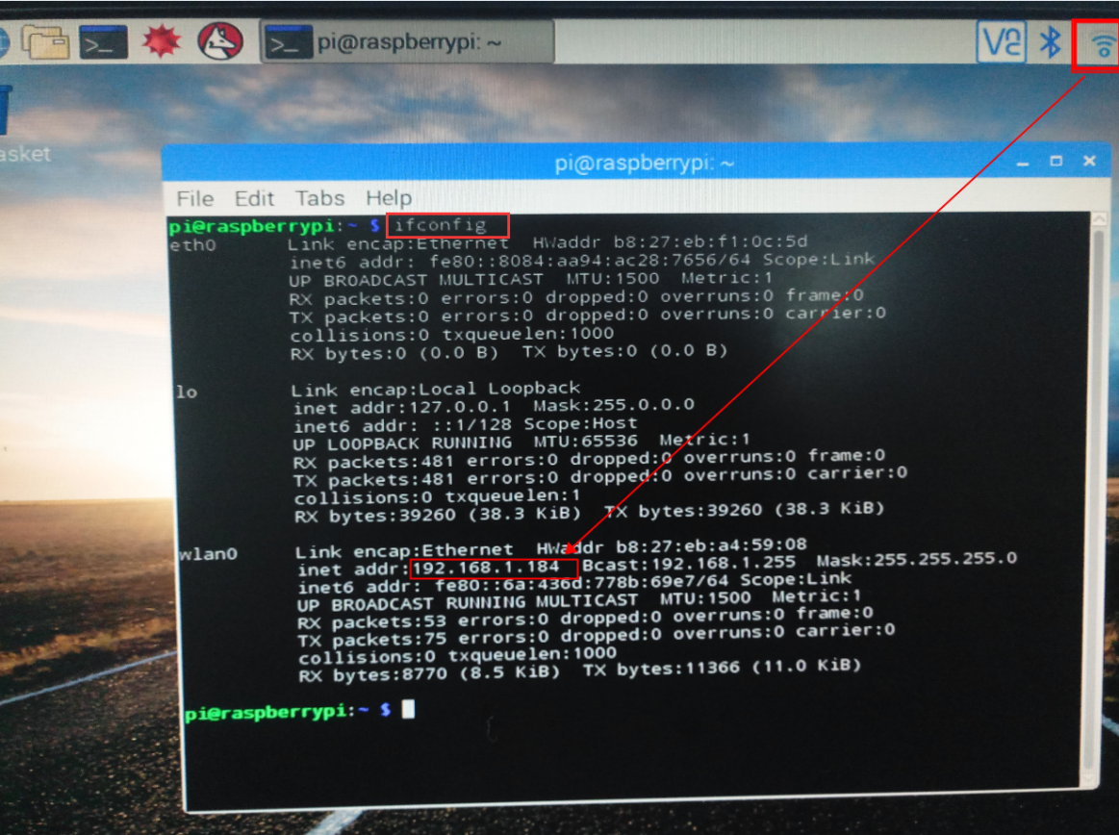

**The following steps will teach you how to open SSH service**

(Note:Official original system image of the Raspberry pi without SSH service, so we need to open this service by ourself.)

1.You need to open the command line terminal in the Raspberry Pi system and input:sudo raspi-config ,as shown in the figure below.

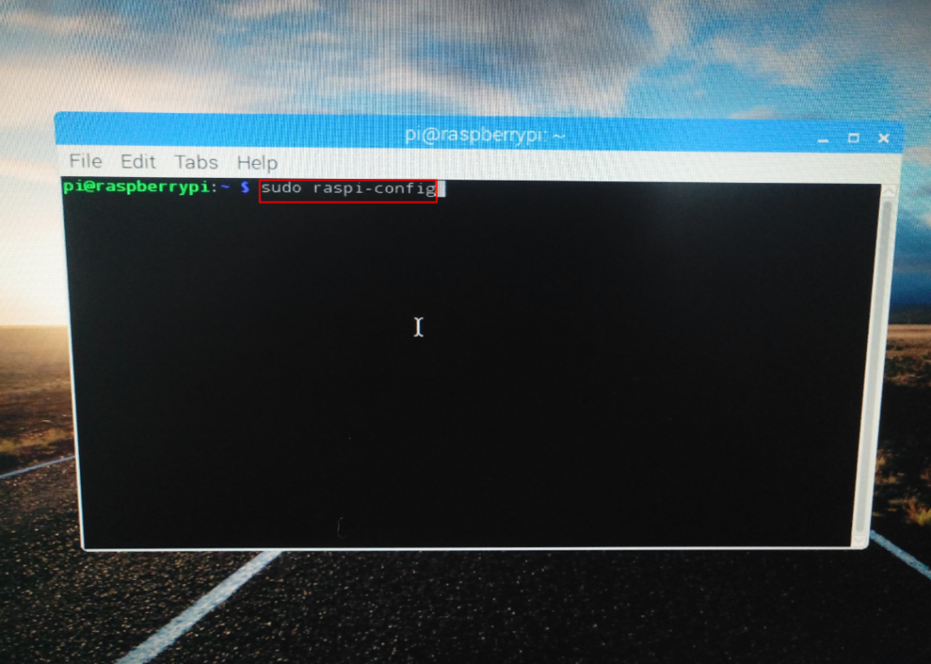

2.You should choose :5 Interfacing Options,as shown in the figure below.

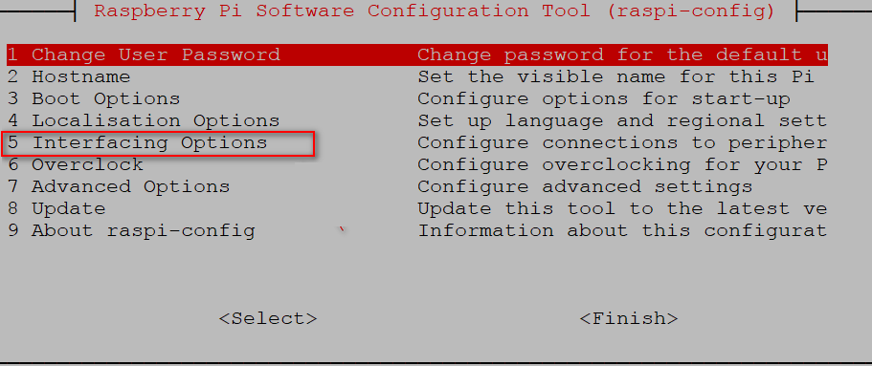

3.You should choose :P2 SSH, as shown in the figure below.

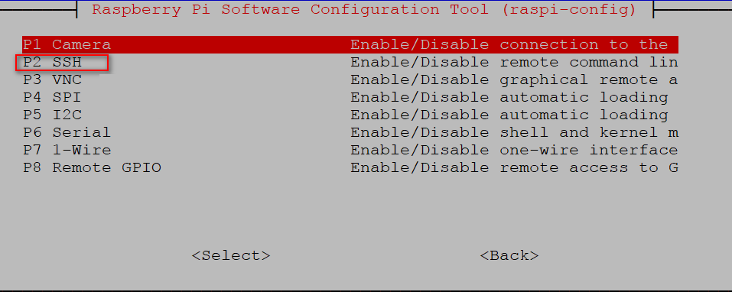

After the above steps, we have opened the SSH service successfully.

After rebooting the system, you can use PuTTY software to remote login into the system.

Official original system image of the Raspberry Pi:

Use name: pi

Password: raspberry

Root password: raspberry

**The following steps will teach you how to obtain IP address**

You need to insert the Internet cable into the Raspberry Pi board, and the indicator light of the Raspberry Pi network port will flash. You can get the IP address of the Raspberry Pi by IP SCAN software.

(Note : This software in the Tools folder)

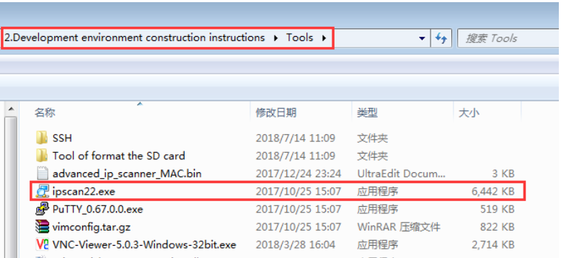

You can double-click to use it.

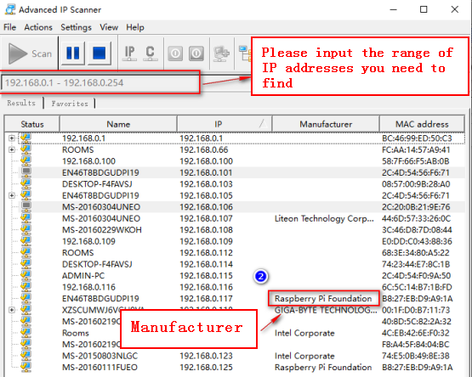

Then you can remote login into the system with this IP address.

**Case2-2: If you don't possess a monitor**

You need to connect the SD card to the computer with a card reader and create a new SSH file(without any format) in this disk.

As shown in the figure below.

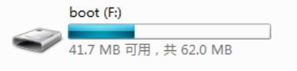



Then, you need to insert the Internet cable into the Raspberry Pi board, and the indicator light of the Raspberry Pi network port will flash. You can get the IP address of the Raspberry Pi by IP SCAN software and enter the Raspberry Pi system by the above method.